- Reflection of light

- Place a sheet of paper on the table in front of  the mirror then use the ruler to trace the pathway  of the beam to and from the mirror.  - Label the incidence beam and the reflective beam.  - Using a protractor, measure these angles in  degrees. Record your results in the table below. | 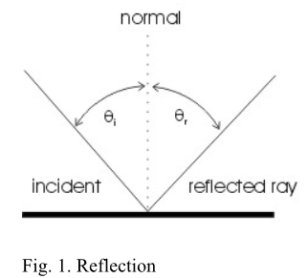

Trial | Angle of incidence θi | Angle of Reflection , θr
1 | 35$°$ | 35$°$
2 | 65$°$ | 65$°$
3 | 20$°$ | 20$°$
4 | 90$°$ | 90$°$
Draw the normal and reflected rays knowing the
Law of Reflection (i=r) . Write the values of the angle of incidence and angle of reflection in the table above
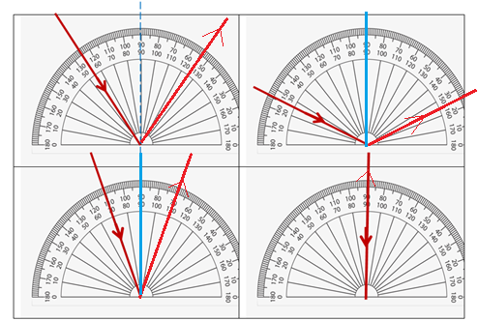

How do the angle of incidence and the angle of reflection compare for each trial?
The value of the angle of incidence and the value of angle of reflection are equal.

B: Refraction of light
Data Processing and Presentation:
Measure the angle of refraction, _{r} for four different angles of incidence _{I} (angles given in the pictures below). In the table below record these angles and calculate and record the sin of angles (i) and the sin of angles (r).
Trial | _{i (deg)} | _{r (deg)} | sin _{i} ) | sin_{r}) | n = sin _{i} / sin _{r}
1. | 50.61 | 35.43 | 0.773 | 0.58 | 1.34
2. | 72.76 | 45.76 | 0.955 | 0.716 | 1.33
3. | 16.68 | 12.43 | 0.287 | 0.215 | 1.33
4. | 87.68 | 48.55 | 0.999 | 0.75 | 1.33

- Calculate the average refractive index of all your data points.
Average refractive index =$\frac{1.34+1.33+1.33+1.33}{4}$ = 1.3325

- Show a sample calculation (numerical values) for your working and explain it.
n = sin _{i} / sin _{r}

n = sin _{i} / sin _{r}
= $\frac{\sin{(50.61)}}{\sin{(35.43)}}=$1.34
= $\frac{\sin{(72.76)}}{\sin{(45.76)}}=$1.33
= $\frac{\sin{(16.68)}}{\sin{(12.43)}}=$1.33
= $\frac{\sin{(87.68)}}{\sin{(48.55)}}=1$.33

N is a refractive index is the ratio of the sine angle of index to the sine angle of refraction.
- Based upon the lab and the class discussion, explain what the index of refraction of a medium tells you about that material?
The index of refraction tells us the measure of the bending of light as it passes from one medium to another through a material. It tells us how much a material refract light as it passes through it. The higher the refractive index, the more the refraction of light.
- If you have two liquids; one with an index of refraction 1.67 and the other with an index of refraction of 1.22 which liquid would cause light to refract the least?
The liquid with refractive index of 1.22. The lower the refractive index of a material the lesser the bending of light as it passes through it.

- Describe where you would appear to a fish looking at you from under water. Draw a sketch.
Light coming from the person refracts when it hits the surface. A fish under water will vie the person appearing above and far away from water surface.
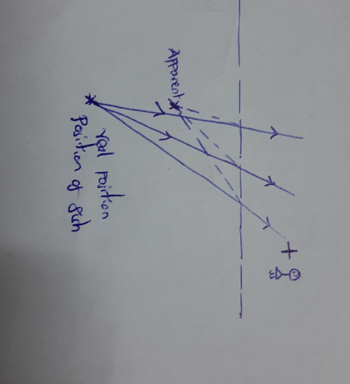

air  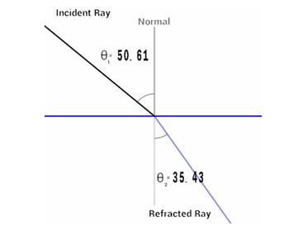  unknown transparent  material | 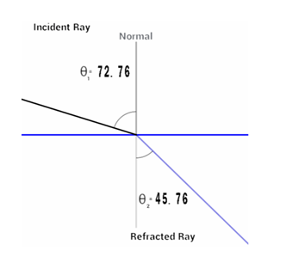
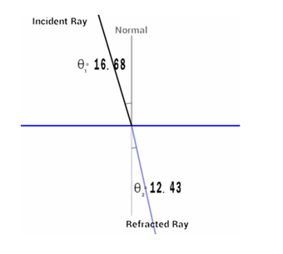 | 